Math 3305 Chapter 2, Section 2.1 Script

Definition of a triangle:

The union of the three line segments joining three non-collinear points.

SMSG Axiom 5

A. Every plane contains at least 3 non-collinear points.

B. Space contains at least 4 non-coplanar points.

Triangle (Geometry)

Tetrahedron

Now Euclid’s Common Notion 4 says: Things that coincide with each other are equal to each other. We need to refine and add to this.

Take two sets of non-collinear points. Make isosceles right triangles of each.

First set: (0, 0), (1, 0), and (0, 1). Second set: (2, 0), (2, 1), (3, 0)

Translate one over the other briefly. Are the points the same ones?

BTW…Hypotenuse is sqrt 2…our new system of finding square roots isn’t the best on 2 and 3, but still works. Comment

We say that the first triangle and the second are congruent. Having the same side lengths and angle measures…but not the same point sets. Congruent concerns itself with measuring and not the actual sets of points themselves.

**Popper 2.1 Question 1**

Congruent and equal mean the same thing.

A. True

B. False

Now if I take the set S = all isosceles right triangles with hypotenuse  . Each of the triangles in the set will be congruent. And if I state that ~ means has the same hypotenuse length. I will have set up (S, ~) an equivalence relation. This is a new concept and it encompasses a HUGE amount of information.

What does it mean if I say a set and a way to compare elements in the set is an “equivalence relation”? Here’s the definition

For elements a, b, and c in S:

1. a ~ a the Reflexive Property holds

2. a ~ b  b ~ a the Symmetric Property holds

3. a ~ b  b ~c  a ~ c The Reflexive Property holds

(recall CN1: Things that are equal to the same thing are also equal to each other.)

Now LOTS of sets and comparatives are NOT equivalence relations. AND not every equivalence relation is very mathy.

Let’s look at a couple that fail

(N, <) Reflexive property

Note the format of the set and the comparative (Set, ~)

New one

S = students in Math 3305 ~ : is older than or equal to

Pick 3 Sam, Mary, and Fred

Reflexive

Symmetric

Transitive

Now let’s look at one that works

S: the set of all isosceles triangles with both side lengths 1 and a right angle

between them

~ : has the same hypotenuse length

Pick three: T1 with the right angle at (0,0); Triangle 2 with the right angle at

(3, 0); and T3 with the right angle at (7,8).

Reflexive

Symmetric

Transitive

The text has good examples on page 38. Note that Example 1 set has some set elements that don’t work and some that do. When this happens, set up a proper subset for the ones that work or pick carefully around the ones that are no good.

Summarizing Equivalence Relation:

**Popper 2.1 Question 2**

An equivalence relation requires a set and ~, a way to compare set elements.

A. True

B. False

Lets talk congruence for triangles!

Now you need to check 6 things to formally conclude that two triangles are congruent: 3 sides and 3 angles. Fortunately SMSG Axiom 15 provides SAS, a favorite shortcut. ASA, SSS, and AAS are theorems and nice shortcuts. The one that everybody wants to work and it doesn’t is SSA (caution here). Let’s look at an example of that.

Let’s look at a triangle with an obtuse summit angle. And use the summit angle as a fulcrum to swing the right hand side inward.

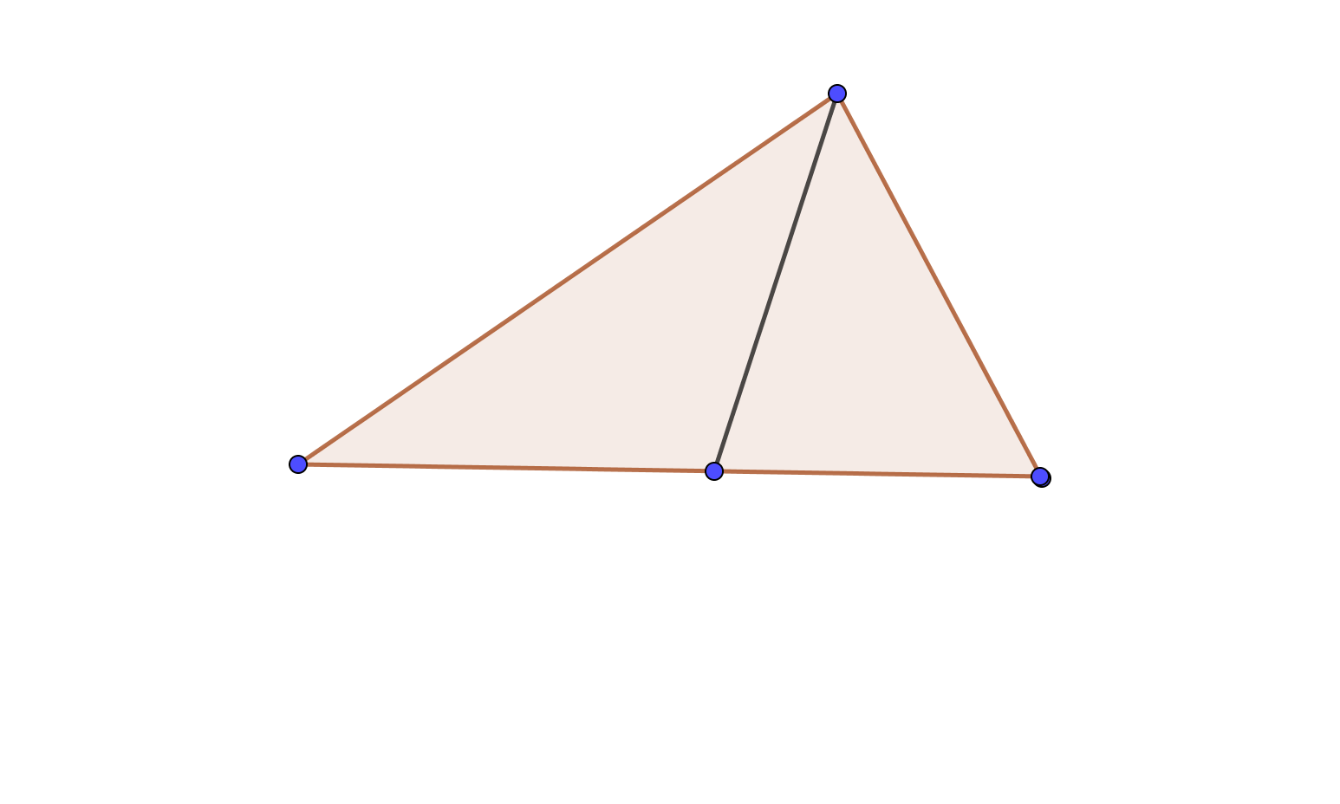

Now let’s spend a minute on triangles in Spherical and Hyperbolic geometry. We have triangles in each. Let’s look at some pictures:

Hyperbolic





Oh my. Add up the angle measures on this one: 125.7. Not consistent! And the Pythagorean Theorem isn’t true!

And now Spherical, with my sketch and your ball and rubber bands.

Let’s look at two of these.

So now we know that we have a Goldilocks and the 3 Bears situation. SG is too big, HG is too small, and EG is just right!

Further, the measure of the interior angles of a triangle is not a constant in our new geometries!

Back to Euclidean!

Now for some vocabulary. Triangles can be categorized by the lengths of their sides or the measures of their angles.

Scalene

Isosceles

Equilateral

Set relations can be shown in two ways depending on your definitions. Our text lists equilateral as a subset of isosceles, but note that not all books do this. Check the text you are teaching from carefully on this point.

**Popper 2.1 Question 3**

In our book equilateral triangles are a proper subset of isosceles triangles.

A. True

B. False

Now for some proofs!

Isosceles Triangle Theorem

Two sides of a triangle are congruent IFF the angles opposite them are congruent.

Proof 1 S A

Proof 2 A  S

And now for another theorem. Let’s review “exterior angles” and remote interior angles.

Theorem 2.1.5 An exterior angle of a triangle is larger than either of the two remote interior angles.

Euclidean:

True in Euclidean and Hyperbolic but not SG

Hyperbolic



Spherical, not true here:

Theorem 2.1.6 (Scalene Inequality). Given two unequal sides in a triangle, the angle opposite the larger side is greater than the angle opposite the smaller side.

**Popper 2.1 Question 4**

Given a 3 – 4 – 5 right triangle, which is the largest angle?

A. Across from the leg measuring 3

B. Across from the leg measuring 4

C. Across from the hypotenuse.

Law of Cosines – a generalization of the Pythagorean Theorem. Strictly Euclidean!

For a right angle at angle C…

Now the Pythagorean theorem says

For a triangle without a right angle, pick an angle C

And the Law of Cosines says

Example:

Note that this term helps you see HOW off the angle C is from a right angle.

Cosine of an acute angle is positive and cosine of an obtuse angle is negative.

Example:



2.1 Essay One

Look up the word “generalization” in the math sense presented here with the Law of Cosines. Explain how this generalization works with scalene triangles that are not right triangles!

Finishing up 2.1

Popper 2.1 – 4 questions

Homework:

#4

#10

2.1 Ms. Leigh One



Use this sketch to show that SSA is not a congruence criterion.

2.1 Ms. Leigh Two



Find the measure of side AB using the Law of Cosines.

Ms. Leigh Essay 1.

Next!